**Practical No 6**

**Aim: Study of Collaboration Diagram**

Collaboration diagrams are used to show how objects interact to perform the behaviour of a particular use case, or a part of a use case. Along with sequence diagrams, collaboration is used by designers to define and clarify the roles of the objects that perform a particular flow of events of a use case.  They are the primary source of information used to determining class responsibilities and interfaces.

**Why use Collaboration Diagram:**

Unlike a sequence diagram, a collaboration diagram shows the relationships among the objects. Sequence diagrams and collaboration diagrams express similar information, but show it in different ways.

Because of the format of the collaboration diagram, they tend to better suited for analysis activities. Specifically, they tend to be better suited to depicting simpler interactions of smaller numbers of objects.  However, if the number of objects and messages grows, the diagram becomes increasingly hard to read.  In addition, it is difficult to show additional descriptive information such as timing, decision points, or other unstructured information that can be easily added to the notes in a sequence diagram.

**Notations of Collaboration Diagram are:**

* Objects
* Actors
* Links
* Messages

**A. Draw Collaboration Diagram for scenario to purchase movie ticket.**

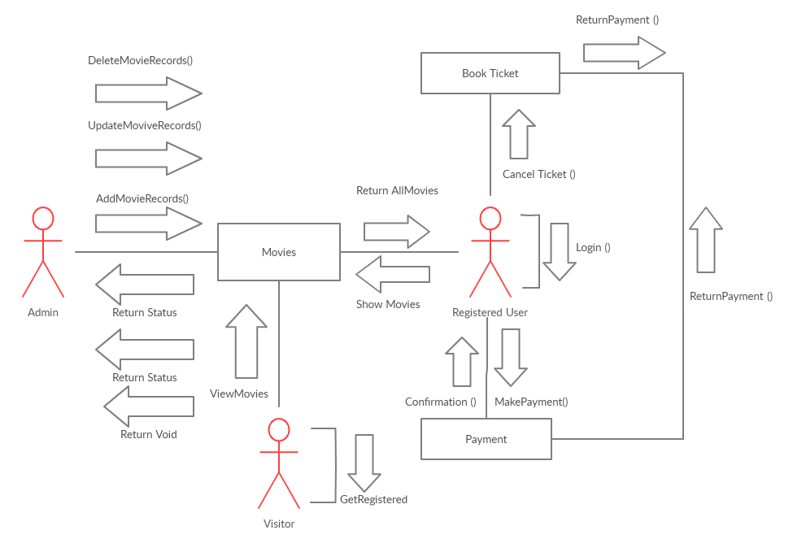

**B. The telephone agent uses an order registry and customer catalog to obtain access to an order & a customer respectively. The order registry uses an order number as a qualifier to select particular order instance. A customer catalog uses customer name and phone number as a qualifier to select particular customer. The attributes of an order are the order numbers and time when it is placed. The order consists of many items. An item has item_number, a quantity, unit price. It also has reference to catalog item which represents listing. When an order is cancelled or committed, it cancels or commits each of its items first. When an order’s total price method is invoked, the order calls the total price method of each of items and returns the sum. The telephone agent wants to cancel the item with item number as I101 from order having order number O123. Show the messages in collaboration diagram for cancellation of item.**

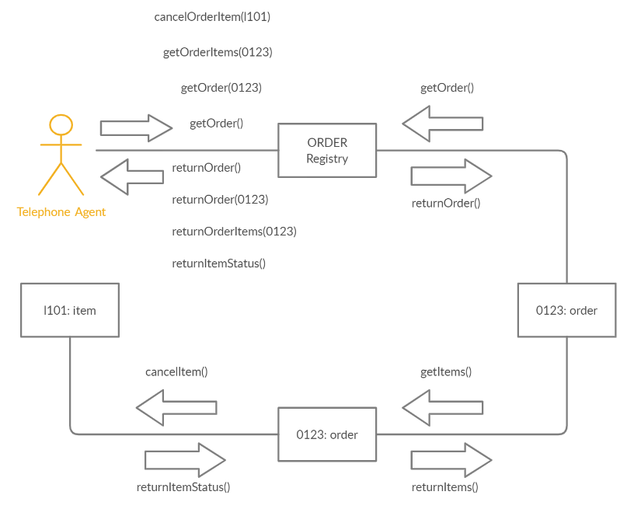

**Conclusion: We have studied the details about the collaboration diagram.**